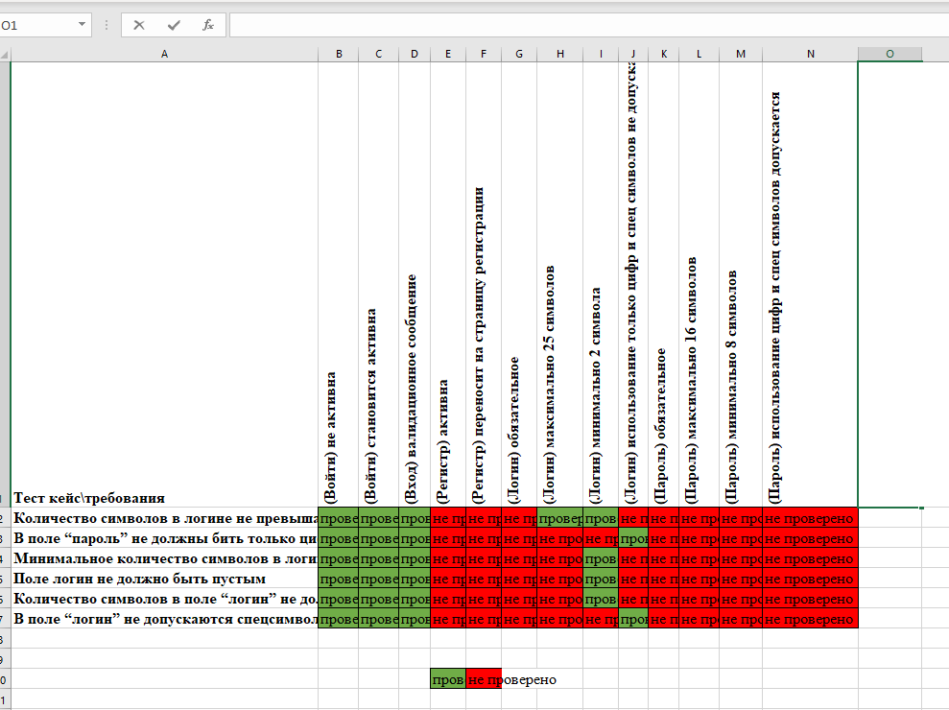

6 / 13 = 46.15 %

